**Summary of Chapter 9**

* **Leader – Someone who can influence others and who has managerial authority**
* **Leadership – What leaders do; the process of influencing a group to achieve goals**

**Three leadership styles ((Kurt Lewin)**

**Autocratic leadership**, also known as authoritarian leadership, is a leadership style characterized by individual control over all decisions and little input from group members. Autocratic leaders typically make choices based on their ideas and judgments and rarely accept advice from followers.

**Democratic leadership**, also known as participative leadership or shared leadership, is a type of leadership style in which members of the group take a more participative role in the decision-making process.

**Laissez-faire leadership**, also known as delegative leadership, is a type of leadership style in which leaders are hands-off and allow group members to make the decisions. Researchers have found that this is generally the leadership style that leads to the lowest productivity among group members.

**Five categories of managerial styles:**

**Impoverished management**

With a low regard for creating systems that get the job done, and with little interest in creating a satisfying or motivating team environment, his results are inevitably disorganization, dissatisfaction and disharmony.

**Task Management**

**Task management** is the process of **managing** a **task** through its life cycle. It involves planning, testing, tracking, and reporting. **Task management** can help either individual achieve goals, or groups of individuals collaborate and share knowledge for the accomplishment of collective goals.

**Middle of The Road Management**

**Middle of the road** is the conservative approach in which the company avoids taking the extremes and focusing on the niche segments. It would target customers in the median range of income or spending tendencies. The main aim is to target the market as broadly as possible.

**Country Club Management**

The **Country Club** or "accommodating" style of **manager** is most concerned about her team members' needs and feelings. She assumes that, as long as they are happy and secure, they will work hard.

**Team Management**

The administration of a group of people assembled to work on a particular project or to perform a particular function within an organization. Team management typically involves setting team priorities and performance objectives, reviewing performance and methods employed, and spearheading the team's decision making process.

**Path-Goal Model**

* Leader’s job is to assist his or her followers in attaining their goals and to provide direction or support to ensure their goals are compatible with organizational goals.
* The main focus is to look at the overall role of the leaders within the group or team.
* The main characteristics of a leader
  + **Being patient**
  + **Being able to motivate**
  + **Having good communication skills**
  + **Providing support and participative by getting involved with the team**
  + **Being fair and not bias**

**Leadership styles under path goal models**

* **Directive**
  + Gives orders and expects the task to be completed at the given timeline.
* **Supportive**
  + Provides the necessary help and guidance to the team and also motivating them to give a positive vibe for the team
* **Participative** 
  + Getting involved and playing a part towards the contribution and helping of the team.
* **Achievement oriented**
  + Focuses towards attaining and getting the job done.

**Path Goal Theory**

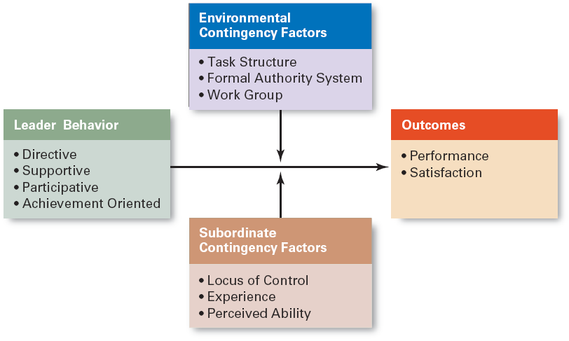

**Leader Behavior**

* The aspect of leader’s behavior looks at the individual’s perception on how they will manage a group with the various styles of dealing and handling individuals
* **Directive**
  + Gives orders and expects the task to be completed at the given timeline.
* **Supportive**
  + Provides the necessary help and guidance to the team and also motivating them to give a positive vibe for the team
* **Participative** 
  + Getting involved and playing a part towards the contribution and helping of the team.
* **Achievement oriented**

Focuses towards attaining and getting the job done.

**Environmental Contingency Factors**

* This focuses towards the type of organization that is being formed
* Looks at the following areas
  + **Task structure** 
    - Here the task has been pre assigned to the respective individuals and all involved will know their roles before hand
  + **Formal Authority System**
    - This looks at the approved reporting structure and rules that are followed by the organization
  + **Work Group**
    - Looks at the group or department that is within the organization.

**Subordinate Contingency Factors**

* Subordinate refers to the level of authority to who is in charge or in power.
* Looks at the following areas
  + **Locus of control**
    - This focuses towards the level of where the individual can control and to what extend they have authority on.
  + **Experience** 
    - Focus towards the overall relevance to the job and looks at the number of years being working in the industry and qualifications that they possess.
  + **Perceived ability** 
    - Looks at the assumptions of what the individual is capable of doing to ensure the job is done.

**Outcome**

* This will evaluate the final result that has been achieved by the group
  + **Performance** 
    - The performance aspect will look at how the group or team has completed and applied their capabilities in terms of their skills and knowledge to get the job done. The focus will be on the leader’s capability and approach of styles towards achieving the intended target.
  + **Satisfaction** 
    - This measures the overall happiness and fulfillment of the members as well as the leader.

**Groups Vs Teams**

|  |  |
| --- | --- |
| **Groups** | **Teams** |
| A number of people or things that are located, gathered, or classed together. | A group of players forming one side in a competitive game or sport. |

* **Team Leadership Characteristics**
  + Having patience to share information
  + Being able to trust others and to give up authority
  + Understanding when to intervene
  + Being supportive
  + Being participative
* **Team Leader’s Job**
  + Managing the team’s external boundary
  + Facilitating the team process
    - Coaching, facilitating, handling disciplinary problems, reviewing team and individual performance, training, and communication